Test Case 1:

|  |
| --- |
| **Login to RefArch site with customer user. Navigate to Product List.** |
| **Select Product**  Choose the product for which Store Inventory has been setup. |
| **Select Store**  When you click the Select Store button, it will open one pop-up window. Here you can search for nearest store to a given zip code. As of now store is configured within “50 miles” for “94043” zip code. |
| **Add to Cart**  After picking the Store – Click “Add to Cart” button.  Note:- You can always change the store using “Change Store” button. |
| **Go to Cart**  Go on top-corner-right and then mouse over on cart icon and click on Checkout button – |
| **Check Out**  On click on checkout button, it will redirect to check out screen. You can see your selected Store |
| **Change Store Option**  You have the option to change the store on Check out page as well. |
| **Payment**  Enter the Email Id as below and CVV code. |
| **Place Order**  Click Place Order button and it will redirect order confirmation page. Note down order number – |
| **Verify Order on GLOVIA OM System**  Go to Salesforce Org, and the check into Sales Order Staging record. You will find the same Order number record – |

Test Case 2:

1. Make Patch from GLOVIA OM
2. Click on Push Order no button on the sales order staging record in GLOVIA OM. This will update the Sales Order Staging No on Commerce Cloud Order and convert this staging record to Actual Order

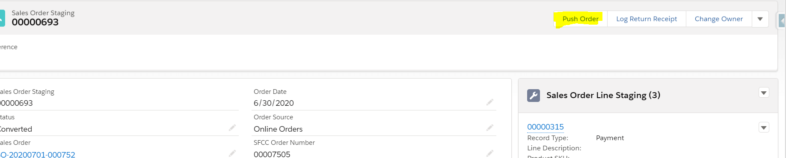

1. Verify the order shows up GLOVIA ORDER Number in External Order Number field into Commerce Cloud
2. The Sale Order Staging No from Glovia OM will be updated as External Order No in commerce cloud order.

